LAB EXPERIMENT
SET 23: EMPLOYEE PERFORMANCE ANALYSIS

Department | AIDS
Course Code / Course Name | DSA0602 / Data Handling and Visualization
Experiment | Data Visualization using R and Tableau
Name | D.HEMASREE
Register Number | 192524114
Date | 15 October 2026
Day | Thursday

Aim
To analyze employee performance data using a bar chart, a line chart and a table in R, and to build an interactive dashboard using Tableau. Dataset: Employee Performance

Employee ID | Department | Years of Service | Performance Score
1 | Sales | 5 | 85
2 | HR | 3 | 92
3 | Marketing | 7 | 78
4 | Sales | 4 | 90
5 | HR | 2 | 76

PROGRAM 1: Bar Chart of Employee Distribution by Department
In R, create a bar chart to visualize the distribution of employees across different departments. Label the chart elements.
# Dataset
employees <- data.frame( Employee_ID = 1:5,
Department = c("Sales", "HR", "Marketing", "Sales", "HR"), Years_of_Service = c(5, 3, 7, 4, 2),
Performance_Score = c(85, 92, 78, 90, 76)
)

# Count of employees in each department dept_count <- table(employees$Department)

# Bar Chart barplot(dept_count,
col = c("steelblue", "darkorange", "forestgreen"), xlab = "Department",
ylab = "Number of Employees",
main = "Distribution of Employees by Department", ylim = c(0, 3))

OUTPUT:
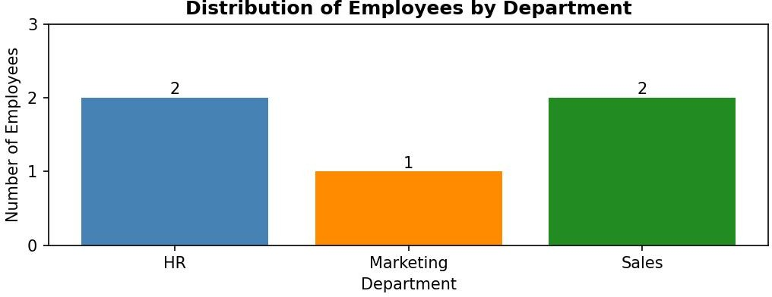
Output 1: Distribution of Employees by Department (Bar Chart)
Observation: Sales and HR each have 2 employees, while Marketing has only 1 employee. The 5 employees are therefore spread across 3 departments, with Sales and HR together accounting for 80% of the staff in the dataset.

PROGRAM 2: Line Chart of Employee Performance Trend
In R, generate a line chart to visualize the performance trend of employees over time. Label the axes and title the chart.
# Order the employees by years of service ord <- order(employees$Years_of_Service)

# Line Chart plot(employees$Years_of_Service[ord],
employees$Performance_Score[ord], type = "o",
col = "steelblue", lwd = 2,
pch = 16,
xlab = "Years of Service", ylab = "Performance Score",
main = "Employee Performance Trend by Years of Service", ylim = c(70, 98))
grid()

OUTPUT:
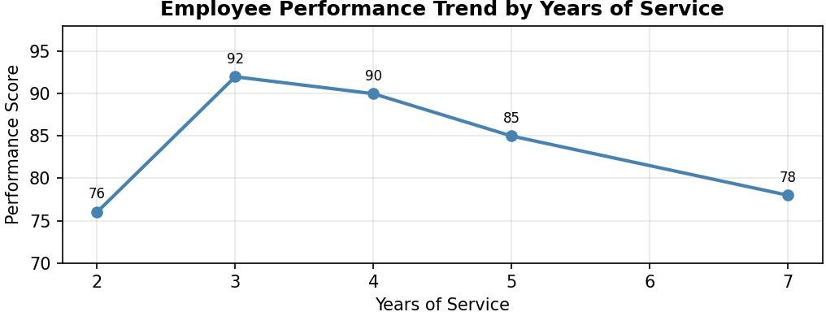

Output 2: Employee Performance Trend by Years of Service (Line Chart)

Observation:
Time is taken as years of service. The performance score is lowest (76) for the employee with 2 years of service and peaks at 92 at 3 years. After that it falls steadily: 90 at 4 years, 85 at 5 years and 78 at 7 years. This suggests that the best scores come from employees early in their service, and that the longest-serving employee has a lower score. With only five employees this is an indication rather than a firm trend.

PROGRAM 3: Tableau Dashboard of Department Distribution and Service vs Performance
In Tableau, build a dashboard combining a bar chart showing department distribution and a scatter plot displaying the relationship between years of service and performance scores.

Steps in Tableau
- Save the data as an Excel or CSV file and connect to it in Tableau (Connect > Microsoft Excel / Text file).
- Sheet 1 (Bar Chart): Drag Department to Columns and Employee ID to Rows, then change the measure to Count (Distinct). Drag Department to Color and add the count to Label. Rename the sheet "Department Distribution".
- Sheet 2 (Scatter Plot): Drag Years of Service to Columns and Performance Score to Rows. Set both measures to Dimension or turn off Aggregate Measures (Analysis > Aggregate Measures) so each employee is a separate point. Drag Employee ID to Detail and Department to Color. Rename the sheet "Service vs Performance".
- Create a new Dashboard (Dashboard > New Dashboard), set the size to Automatic, and drag the two sheets onto the dashboard area.
- Add interactivity: select the bar chart and click Use as Filter, so clicking a department bar filters the scatter plot. Add a Department filter (Show Filter > Apply to Worksheets > All Using This Data Source).
- Add the title "Employee Performance Dashboard" and test the filters in Presentation Mode.

OUTPUT:
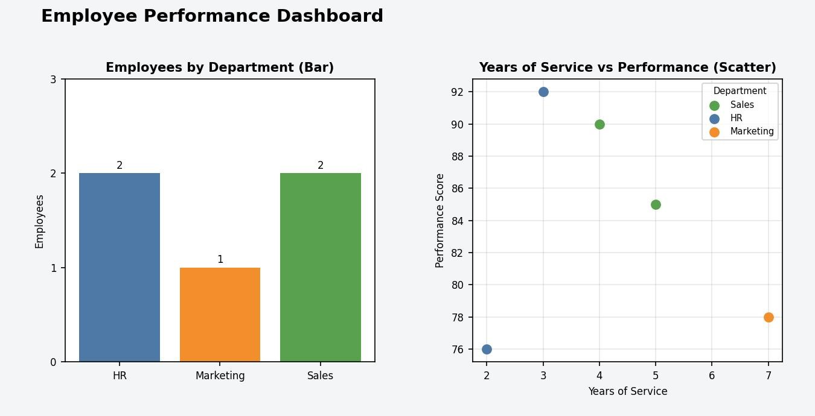
Output 3: Employee Performance Dashboard (Tableau)

Observation:
The dashboard shows the department headcount and the relationship between years of service and performance together. The scatter plot points are scattered with no clear pattern: the correlation between

years of service and performance score is about -0.17, which is a weak negative relationship. Years of service alone therefore does not explain performance in this small dataset. Clicking a department bar highlights only that department's employees in the scatter plot.

PROGRAM 4: Table of Performance Data for Each Employee
In R, develop a table showing the performance data for each employee. Label the table elements.
# Performance data for each employee print(employees)

# Summary of the performance data mean(employees$Performance_Score)
aggregate(Performance_Score ~ Department, data = employees, FUN = mean)

Console Output

Employee_I  1 |  | D  1 | Department  Sales | Years_of_Service Perform  5 | ance_Score  85
2 |  | 2 | HR | 3 | 92
3 |  | 3 | Marketing | 7 | 78
4 |  | 4 | Sales | 4 | 90
5 |  | 5 | HR | 2 | 76
[1] 84.2
Department Performance_Score
1 | HR | 84.0
2 | Marketing | 78.0
3 | Sales | 87.5
Output 4a: Employee Performance Table (R Console)

Employee ID | Department | Years of Service | Performance Score
1 | Sales | 5 | 85
2 | HR | 3 | 92
3 | Marketing | 7 | 78
4 | Sales | 4 | 90
5 | HR | 2 | 76
Output 4b: Employee Performance Table

Observation:
The table gives the exact performance data of every employee. The average performance score is 84.2. Employee 2 (HR, 3 years) has the highest score of 92, and Employee 5 (HR, 2 years) has the lowest score of
76. By department, Sales has the highest average score (87.5), followed by HR (84.0) and Marketing (78.0).

Procedure
- Create the employee performance data frame in R with Employee ID, Department, Years of Service and Performance Score.
- Use table() to count the employees in each department and barplot() to draw the bar chart.
- Order the data by years of service and use plot() with type = "o" to draw the line chart.
- Load the employee file into Tableau and build the bar chart and scatter plot worksheets.
- Combine the worksheets in a Tableau dashboard and add filters and actions for interactivity.
- Display the data frame with print() and calculate the averages with mean() and aggregate().

RESULT:
The employee performance data was successfully analyzed using a bar chart, a line chart and a table in R. An interactive Tableau dashboard was also created, combining the department distribution bar chart and the years of service versus performance scatter plot so that users can explore the data by department.

Key Functions and Tools Used

Function / Tool | Purpose
data.frame() | Creates the employee performance table.
table() / barplot() | Counts employees per department and draws the bar chart.
order() / plot(type = "o") | Sorts by years of service and draws the line chart.
print() / aggregate() | Displays the table and finds average score by department.
Tableau Bar / Scatter | Builds the department bar chart and the scatter plot.
Tableau Dashboard | Combines worksheets with filters and actions.

